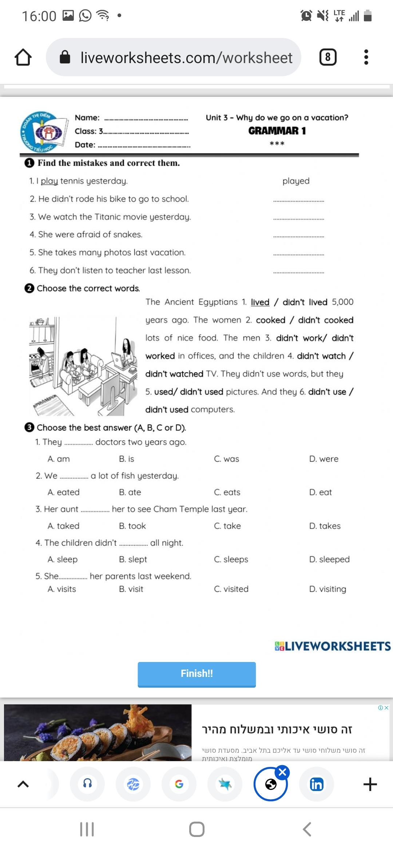

Present……..Past

Ride ……. Rode

Was. ……... Were

Take ……… . Took

Do not…… Did not

